Mitosis

Group Members:
Adeel Ahmed, Jeremy Bagay, Roby Yeung
Date:
November 1, 2007

Materials List
PowerPoint presentation, which requires projector and computer
A video clip from the TV show “Heroes” showing spontaneous regeneration
Slides of plant cell zooming in on the intracellular level
4 different colours of Play-doh
Diagram of Mitotic process

Safety Consideration
Make sure none of the students are allergic to the Play-doh and warn students not to use it in improper ways.

Connections with the Manitoba Framework of Outcomes
S1-1-01 Illustrate and explain the process of mitotic cell division in plants and animals.
GLO: D1, E1, E2
S1-1-02 Observe and explain the dynamic nature of cell division.
GLO: C2, D1, E3

Learner Preconceptions and difficulties with the topic
According to Rosalind Driver, some learners have troubles with differentiating between a cell and a molecule. Younger learners aged 11 have demonstrated this by drawing cells when asked to draw molecules. Many of them believed that cells make up bigger, larger organisms while many mistook carbohydrates, proteins, and water to be made up of cells. Learners tend to think of molecules as being confined to Physics and Chemistry. This was evident when students thought molecules made up heat and energy but not living things.
The concern would be that students may think that smaller parts of the cells such as chromosomes and vacuoles to be molecules. Although this preconception is mostly seen in younger students, it is possible that some of these ideas carry on through to the high school stages of their learning. One way the concepts of chromosomes and nucleus can be clarified in regards to mitosis would be to make sure that it is explained what these parts do and what their function is in the cell. A slide in the experiential level will also show a slide that is slowly magnified to the cellular level. This may help in solidifying concepts about cells.

The Experiential level
To introduce the topic and mostly to grab the students’ attention, a video clip from the TV show heroes will be shown. The clip is one of the characters that has the ability to instantaneously and spontaneously regenerate. The teacher will ask about what is happening to the girl. Students will be expected to respond in ways such as she is repairing herself. The students will then be asked to think if to some extent we are able to do the same. The teacher will talk about how to a certain extent we are, but not nearly to the same rate or degree. The teacher should also note not to go into the topic of the girl’s superpowers too deeply but rather refocus the students by getting them to bang their hands on the desk. This activity should bring the experience of the activity back to the student. The teacher can explain that when we bang our hands on the table, cells are dying and they are also being replaced. From here, we can make the connection that mitosis is involved in reproducing cells that become replacement for those that we lose. To make this concept even clearer, a slide will be shown of a plant. The view of the slide will zoom in until it reaches the cellular level, further illustrating that the cells make up the plant. It is in this level that the explanation of mitosis will begin. This process will also serve as transition into the psychological level.
Through the pictures shown, students should be able to connect where the concept of mitosis fits in the real world. Further explanation in the psychological level will provide a clearer understanding of the mitotic division process.

The Psychological level
The Play-Doh will be passed around to student groups. The students will be told that mitosis is how cells replicate so that they contain the right information that tells the cell what it is supposed to do. The process of mitosis is concerned with making a daughter cell, which is most of the time an exact copy of the parent cell (the cell it was copied from).
The students will be told the stages of the replication process and they will try to follow along and at times figure out the next parts of the activity. The steps will be as follows:

- Have the students make a cell by creating the following with their play-doh
  - Green square representing the cell wall
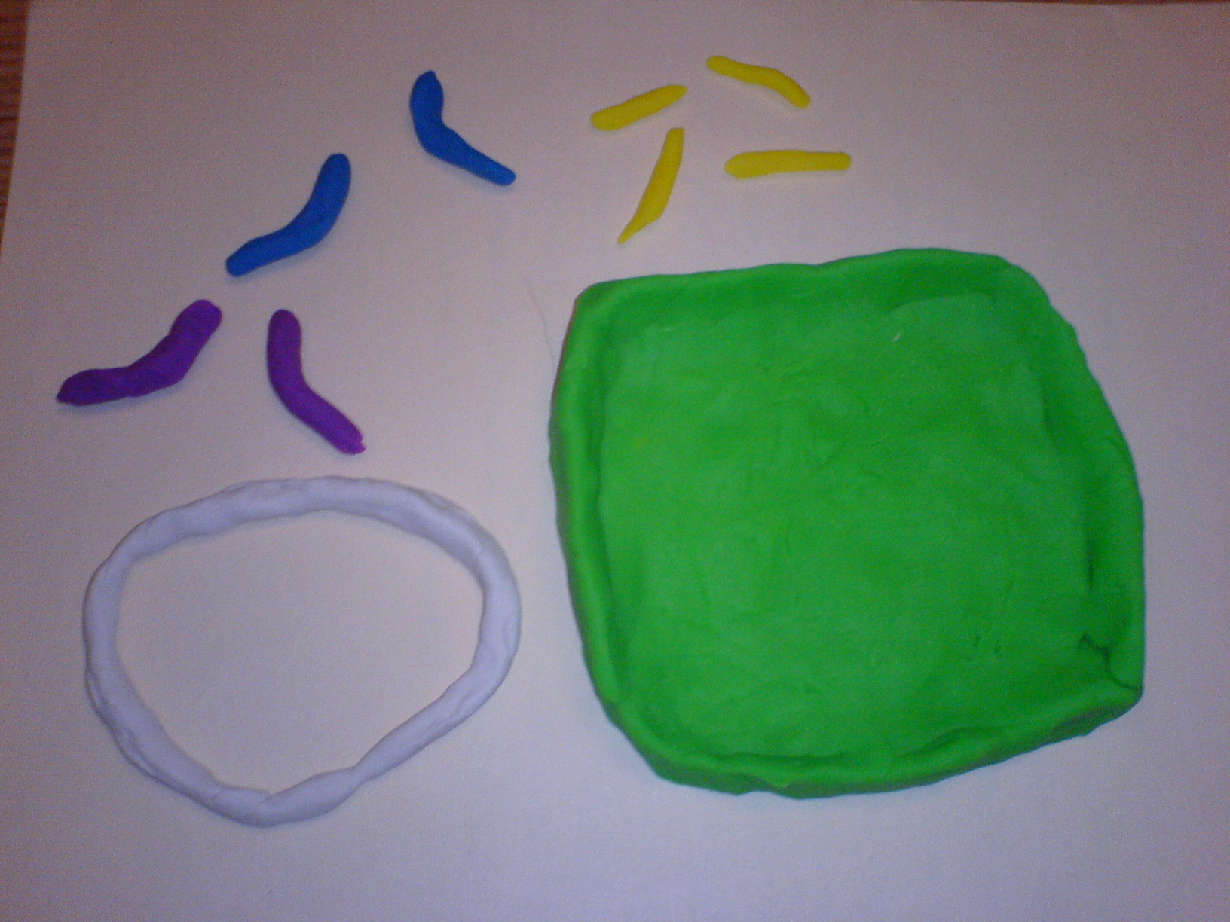
  - Another white circle within the green circle representing the nucleus
  - One blue strand and another purple strand within the white circle
  - Yellow strands that are outside the nucleus representing microtubules
It should be explained to the students that this is not the same colour of the organelles in real life but are rather used for designation.
At this point the teacher may explain some of the terms that will be used to name the structures.

- The teacher will tell the students that the first thing that needs to happen is for the chromosomes to replicate. Ask the students how they think something like this will happen or look like using the play-doh. Allow the students a few seconds to figure it out for themselves and see what they come up with. The teacher will then demonstrate by adding another piece of blue and purple strand to each chromosome. The teacher can explain that these two strands are now each called a chromatid. It can also be explained at this point that the structures become shorter and thicker and can be modeled with the Play-doh accordingly.
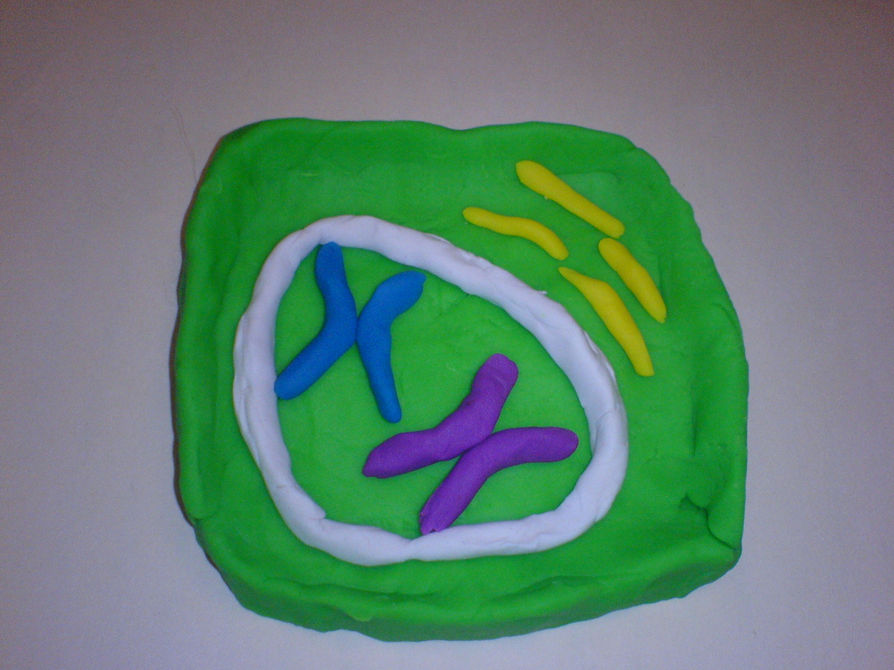
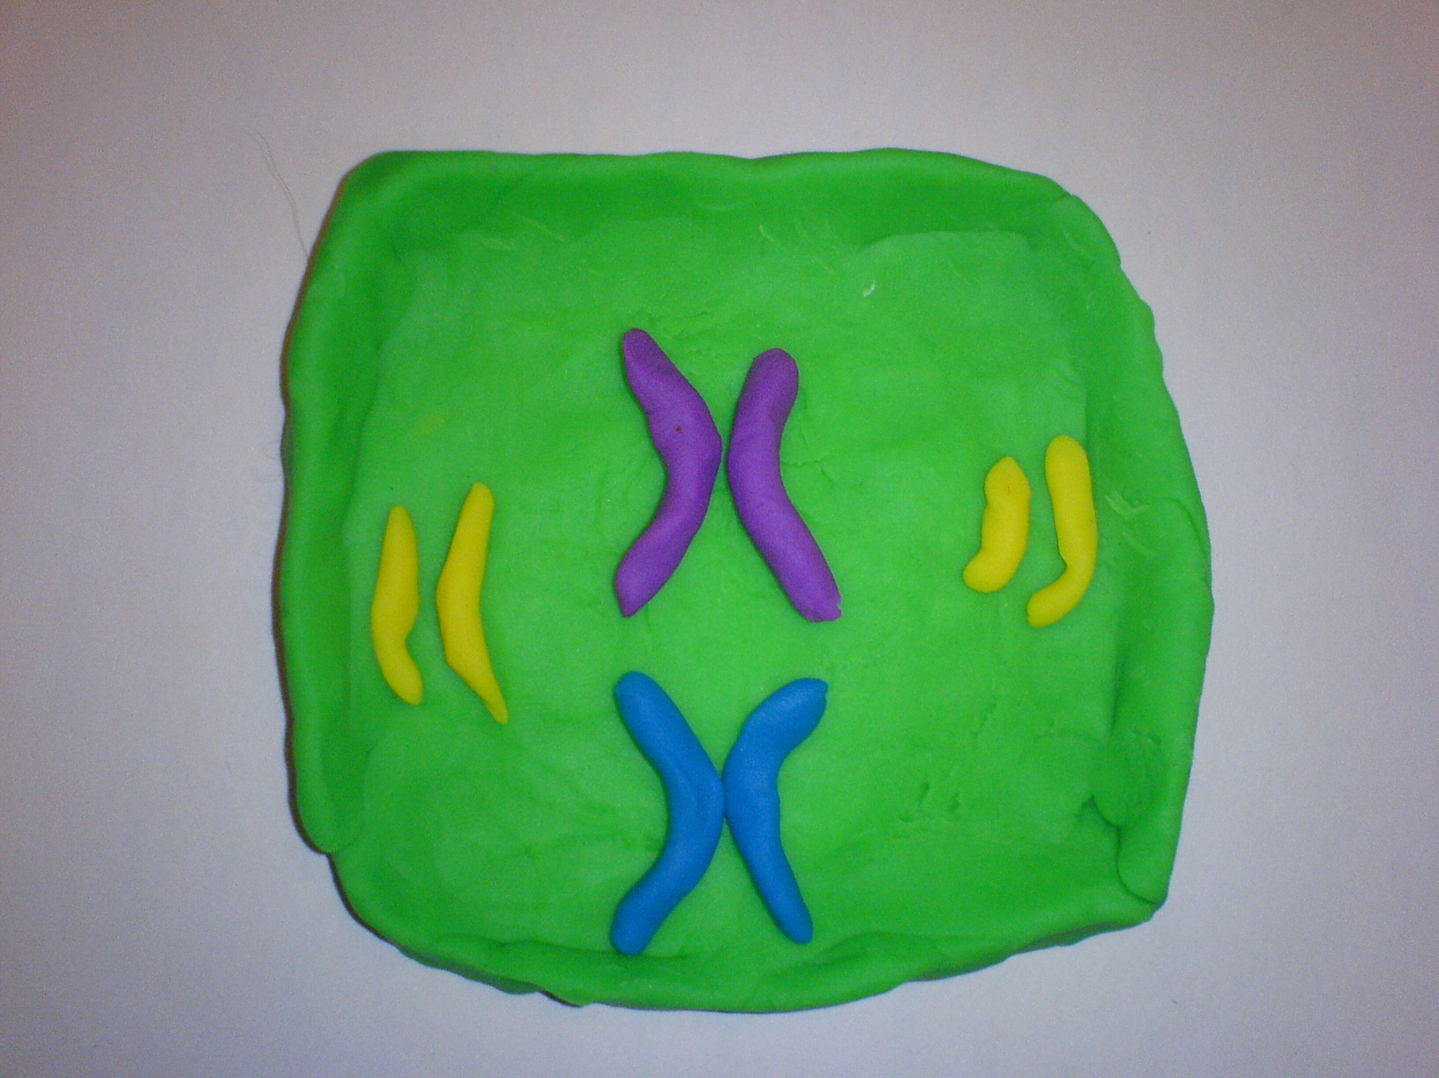
- Tell the students that the wall around the nucleus at this time disappears or disintegrates. What would happen to the chromosomes? Some might say that they will just float around. At this point the teacher points out the yellow strands and explain how they help the chromosomes to line up in the middle of the cell.

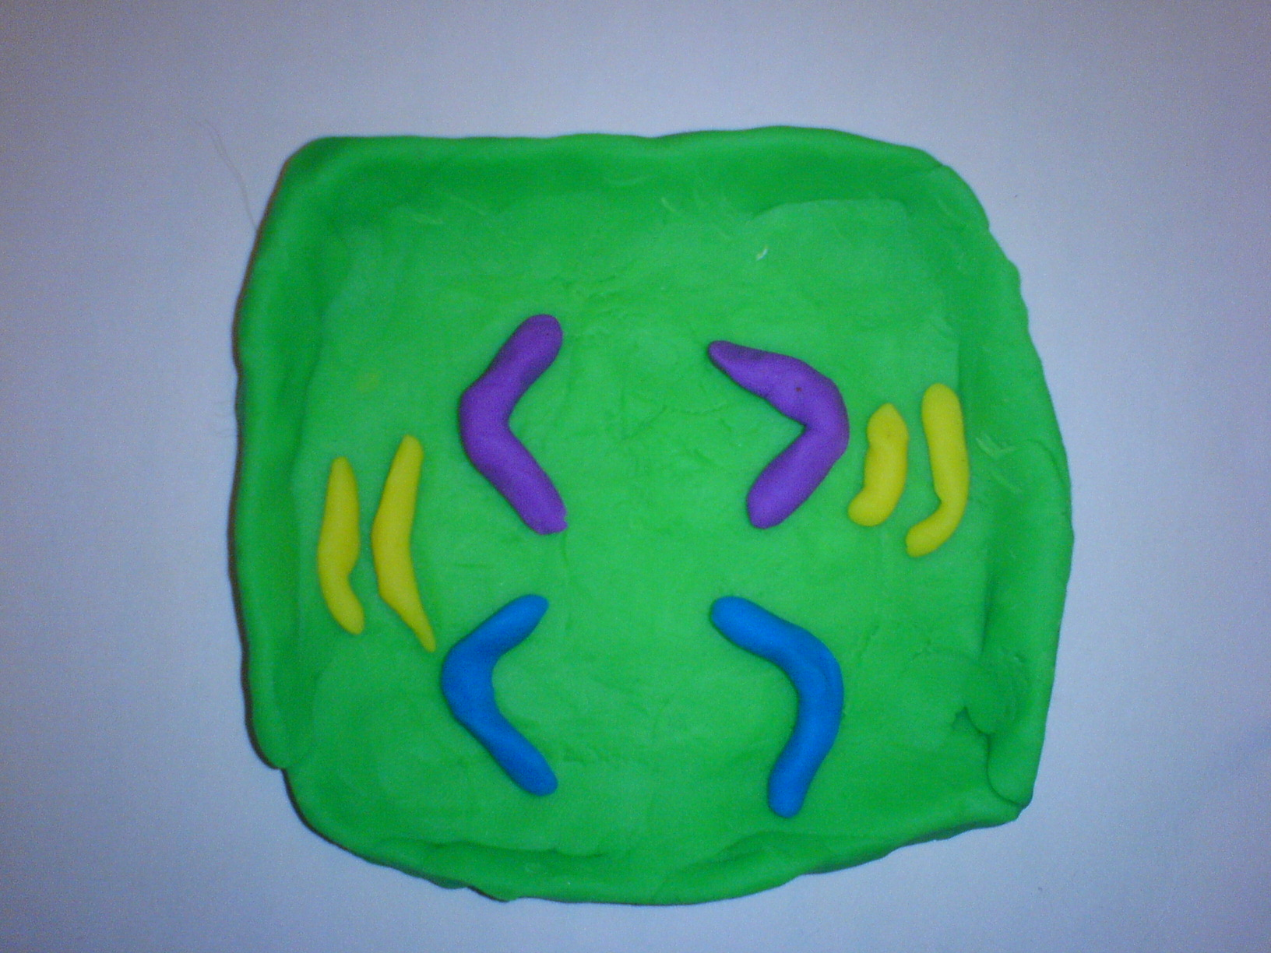
- At this point tell the students that the cell is ready to split. Ask them how they think that this could be done. Remind them that both cells have to contain the exact same things. When the students have given their ideas the teacher can explain that the chromatids separate into chromosomes and the cell divides. This can be illustrated by cleaving the green boundaries in half.

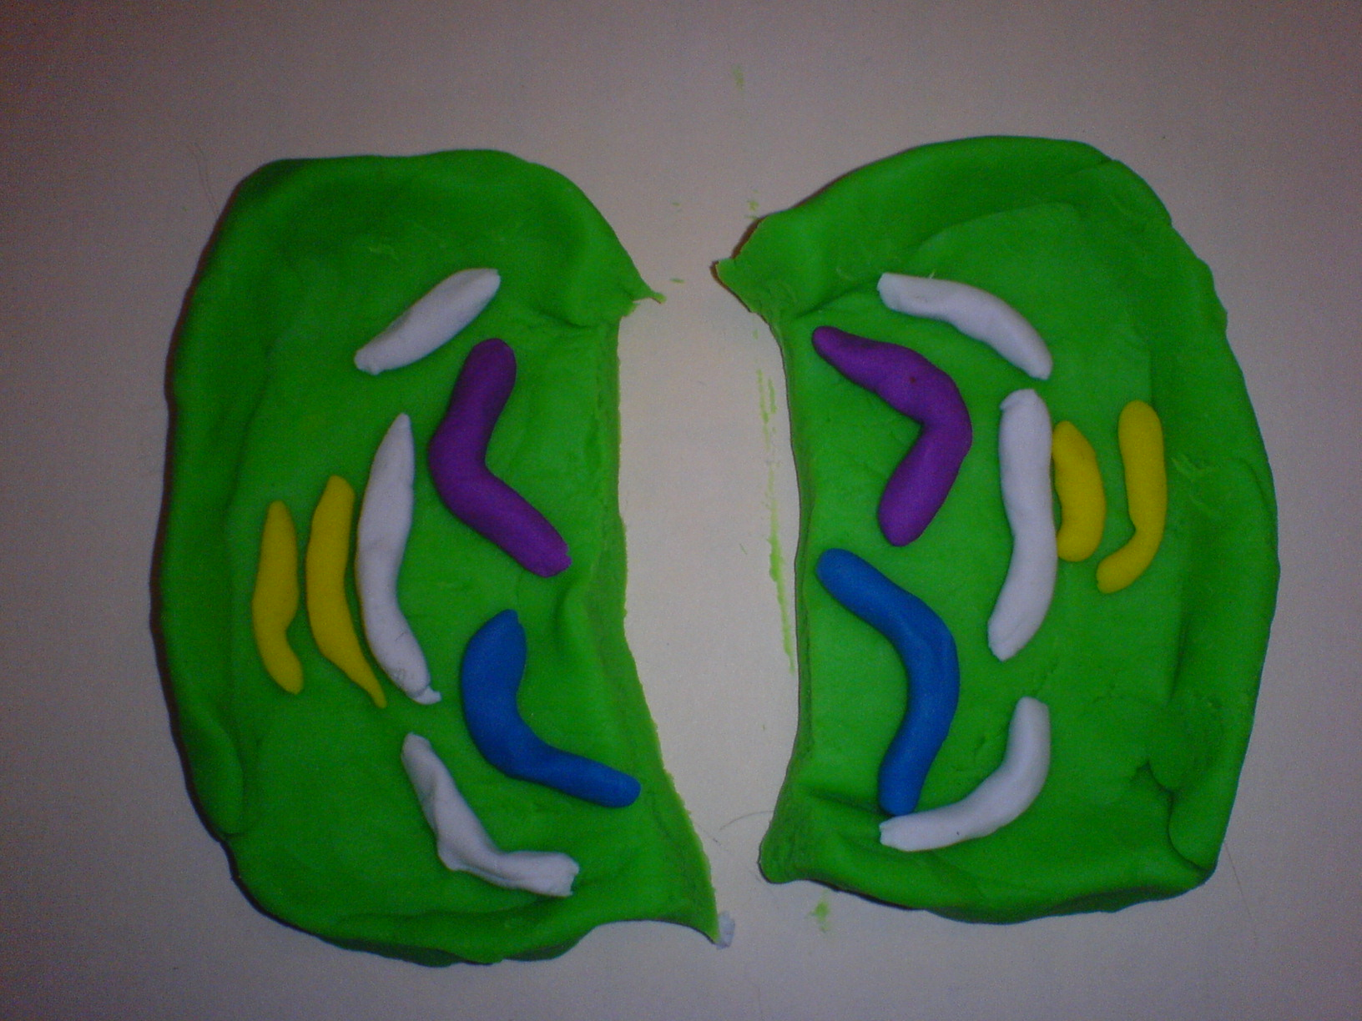
- The result is two cells containing the same amount of chromosomes. Explain to the students that this process in which the cytoplasm is divided is called cytokinesis. While the cell is dividing, a new nuclear envelope forms around the chromosomes. It should be noted that cytokinesis is a separate event from mitosis but rather is happening the same time as the late stages of mitosis.

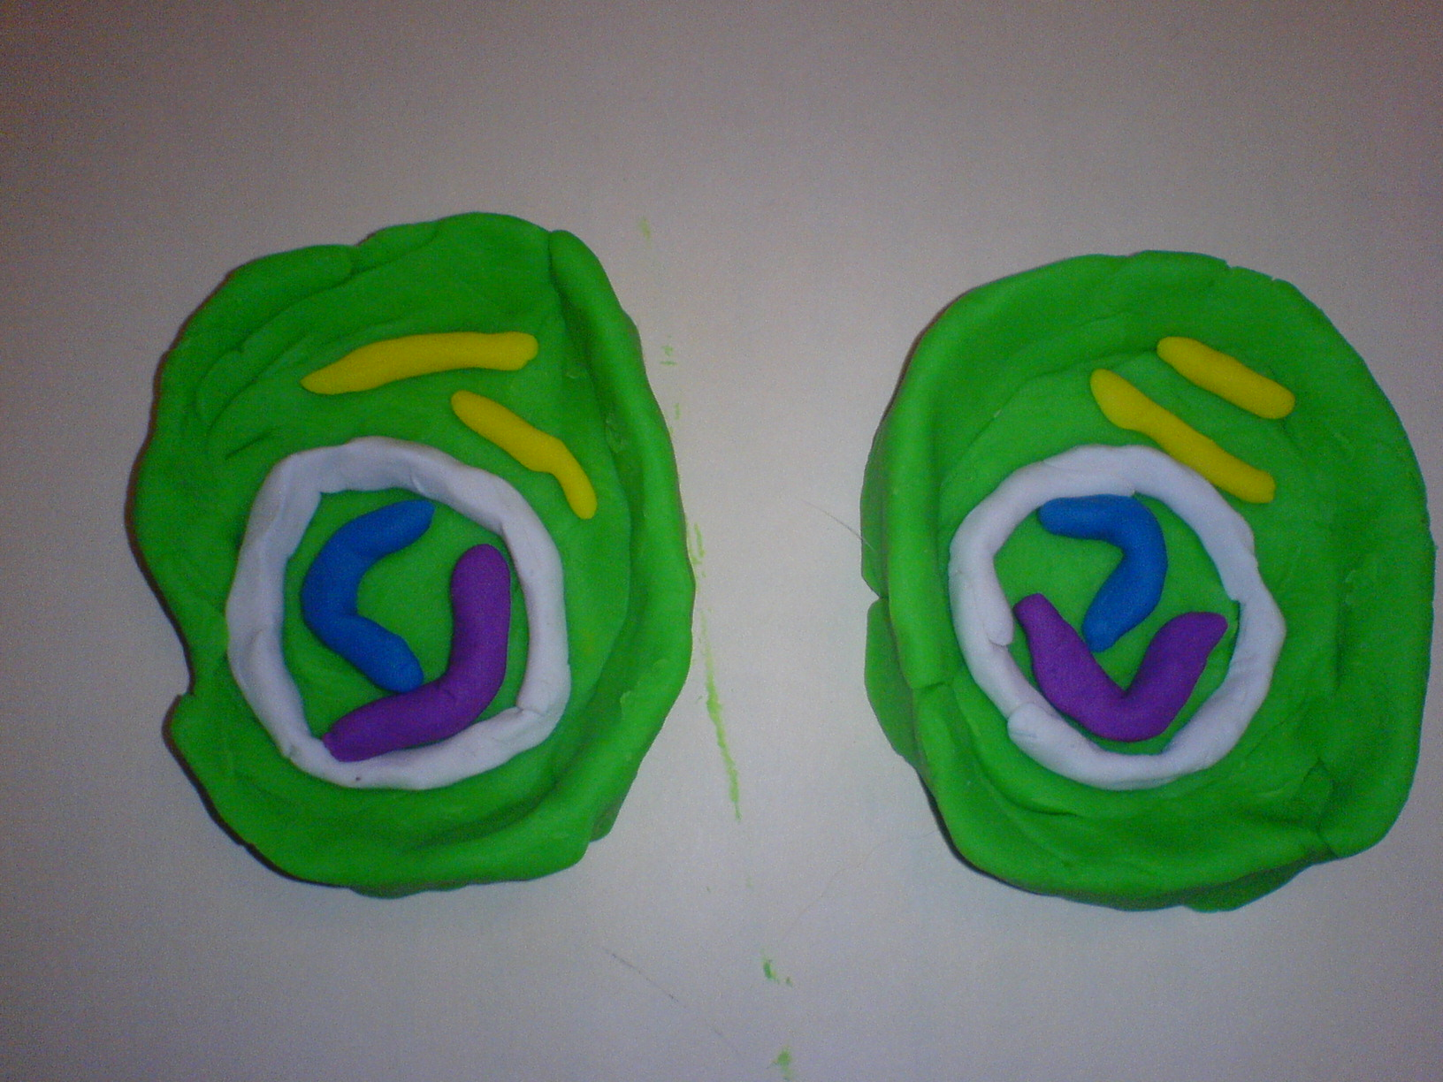
- Explain to the students that as the two cells are produced, they will grow and continue on in the mitotic division process.

Theoretical level
The teacher will explain that the process they went through was done so that a cell can duplicate the genetic information that it has. As a whole, mitosis is a part of a cycle that is involved in creating new copies of itself and follows a period in which the cell grows. The genetic information determines the function of the cell. For example it might be a cell that is part of the outer covering of a plant. The teacher will go through the definitions of the terms used in explaining mitosis and at the same time show a diagram that will reveal a step-by-step illustration of mitosis.
The teacher will ask the students to pay attention to the different parts of the cell.
The chromosomes are molecules that contain the genetic material.
The cytoplasm is the watery substance inside the cell. It is everything that is not including the nucleus and is inside the plasma membrane (green boundary).
The yellow structures in the cell were microtubules. They pull on the chromatids enabling them to separate from each other.
As a quick review the teacher can again go over the phases this time mentioning but not emphasizing each stage in the process. The teacher can then get the students to align all the organelles in their proper places depending on the stage. The teacher will go from Prophase to Telophase. At this point the teacher can point out that they started with one cell and ended up with two. A question about how many chromosomes were there in the start and the end can also be asked. This will emphasize the replication that has taken place.

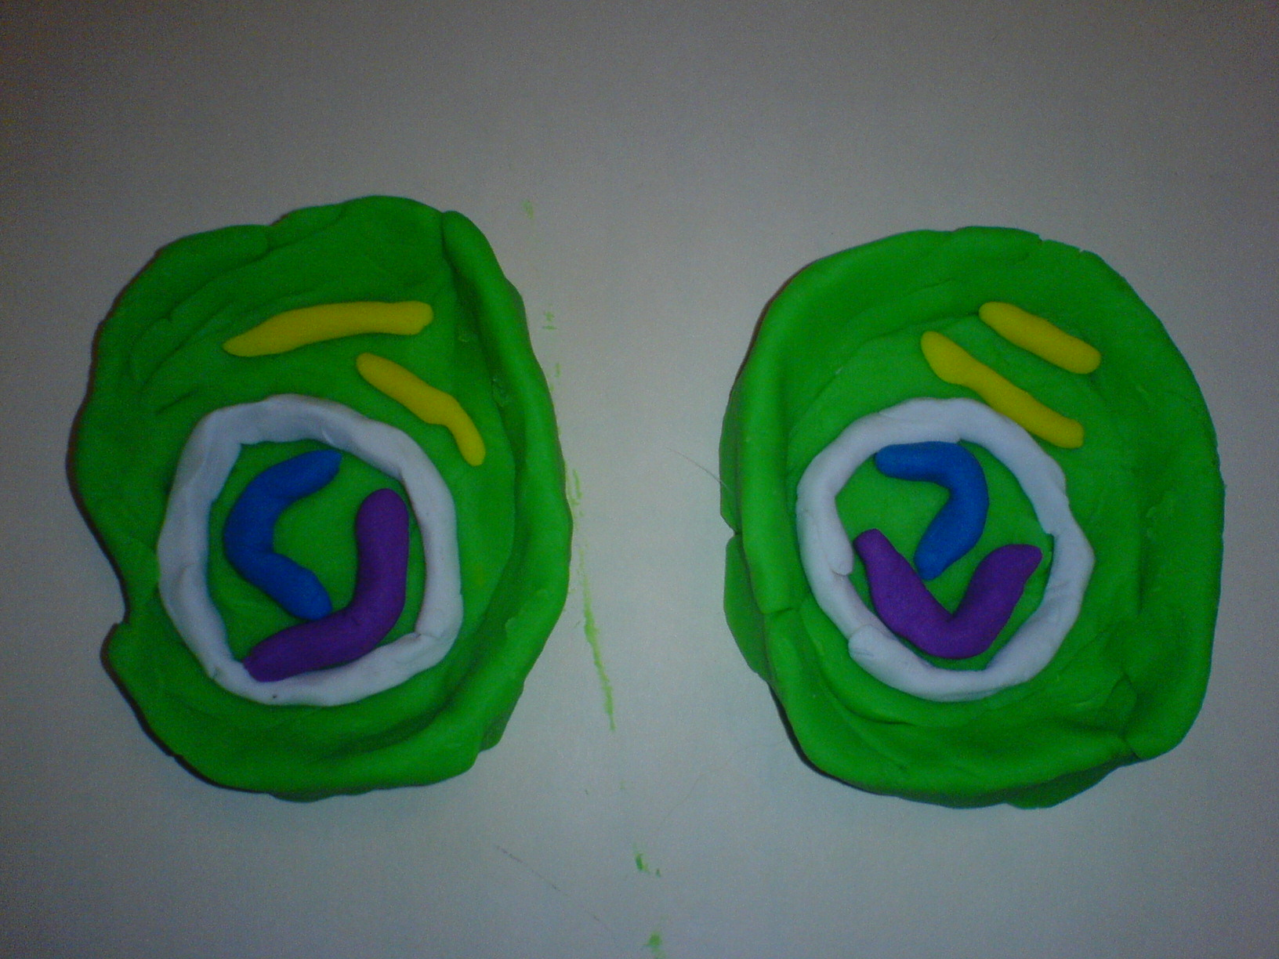

References:
Driver, Rosalind. Making Sense of Secondary Science: Support Materials for Teacher. Routledge. New York. 1993

Campbell, Neil A. Biology. Benjamin/Cummings Publishing Company. Menlo Park. 1996

